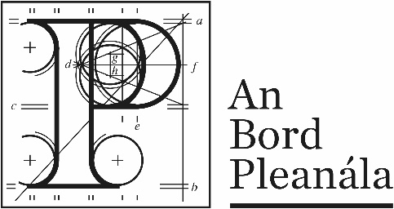
Documents received at Oral Hearing for ABP-310286-21

Case Description | Railway works and all works necessary to eliminate and, where necessary, upgrade seven numbered level crossings and carry out all associated and ancillary works along a 24-kilometre section of the Dublin to Cork Railway Line, Co. Cork and Co. Limerick
Date | 27th and 28th September, 2022
Location | Longcourt House Hotel, Newcastle West, Co. Limerick

Documents received at Oral Hearing
No. | Submitted by | Presenter | Topic
1 | Iarnród Éireann | David Vaughan | Opening statement & background
2 | Iarnród Éireann | Gerry Healy | Brief of Evidence – Overview of Railway Order and Railway works
3 | Iarnród Éireann | David Dineed | Property referencing
4 | Iarnród Éireann | Rory Mc Donnell | Brief of Evidence - Planning
5 | Iarnród Éireann | Rory Mc Donnell | Brief of Evidence – EIA Co-ordination
6 | Iarnród Éireann | Heidi Sewnath | Brief of Evidence – EIAR, Population, Health & Surface
7 | Iarnród Éireann | Dr. Susie Coyle | Brief of Evidence - Biodiversity
7a | Iarnród Éireann | Dr. Susie Coyle | Mitigation Strategy
8 | Iarnród Éireann | Dr. Susie Coyle | Brief of Evidence – Natura Impact Statement
9 | Iarnród Éireann | Gerry Healy | Agreement between Iarnród Éireann and Limerick City and County Council
10 | Iarnród Éireann | Colin Wyllie | Brief of Evidence – Traffic and Transport
11 | Iarnród Éireann | David Dineen | Brief of Evidence – Property Referencing
12 | Iarnród Éireann | Chris Conroy | Brief of Evidence – Noise and Vibration
13 | Iarnród Éireann | Bryn Coldrick | Brief of Evidence – Cultural Heritage
14 | Iarnród Éireann | Richard Barker | Brief of Evidence – Landscape and Visual
15 | Observer -Patrick O’Donovan TD | Patrick O’Donovan TD | Brief of Evidence
16 | Observer - Mike Donegan | Mike Donegan | Brief of Evidence
17 | Observer - Gabriel Clery | Gabriel Clery | Brief of Evidence
18 | Observer - Ballyhea National School – Board of Management | Marie O’Hanlon-Mc Inerney | Brief of Evidence
18a | Observer - Ballyhea National School – Board of Management | Marie O’Hanlon-Mc Inerney | Brief of Evidence
19 | Observer - Trustees of the Diocese of Cloyne | Mary O’Connor | Brief of Evidence – Ecology
20 | Observer - Trustees of the Diocese of Cloyne | Denis Mc Namara | Brief of Evidence – Bats
21 | Observer - Michael O’Kelly | Michael O’Kelly | Brief of Evidence
22 | Observer – Cork County Council Age Action Group | Maurice O’Riordan | Brief of Evidence
23 | Iarnród Éireann | Gerry Healy | Agreement between Iarnród Éireann and Cork County Council
24 | Observer – Hilton Lowell | Hilton Lowell | Brief of Evidence
25 | Observers – Noel & Margaret Hanley | Michal O’Kelly | Brief of Evidence
26 | Observers – Noel & Margaret Hanley | Michal O’Kelly | Brief of Evidence – Report by Big Hill Associates
27 | Observer - Bernadette Leahy | Bernadette Leahy | Brief of Evidence
28 | Iarnród Éireann |  | LVIA submissions responded to numbered within precis
29 | Observer – Ballyhea Community Hall Committee | Geraldine Egan | Brief of Evidence
30 | Iarnród Éireann |  | Schedule of Mitigation updates – 28/09/22
31 | Iarnród Éireann |  | Appendix 1L: Scheduler of Mitigation – March 2021
31A | Iarnród Éireann |  | Appendix 1L: Scheduler of Mitigation – September 2022
32 | Iarnród Éireann |  | Statutory Instruments – SI No. 743 of 2021

